Application Deployment Guide--windows System
- Install ADB Environment
Download and install directly via the link below:
platform-tools.zip
- Configure ADB Environment Variables
After extraction, add the extraction path to the system's Path environment variable:
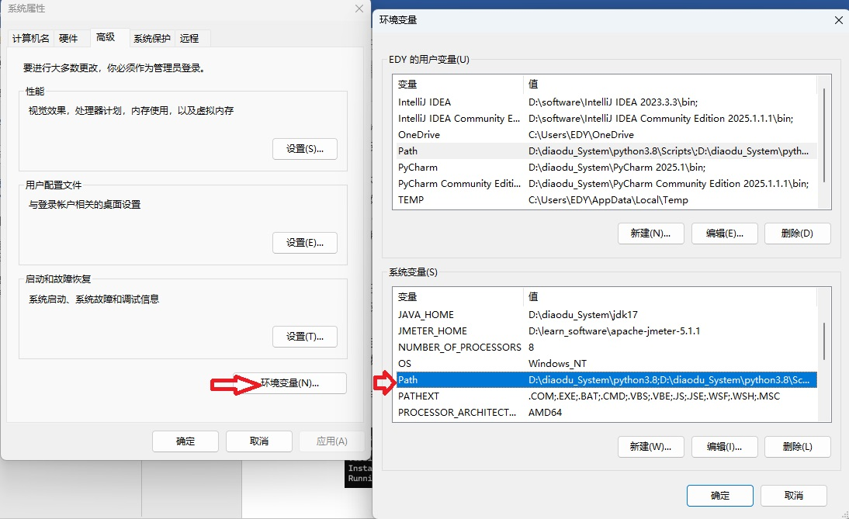
- Open CMD Window on Computer
Input “adb version”:Display the ADB version to confirm successful installation.
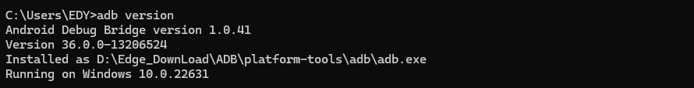
- Connect: Via USB Cable
- Operation: Navigate to Settings > Accessibility on the screen, find the OTG to USB switch, and turn it OFF:
- Input “adb devices”
Check Currently Connected Devices. Connected devices will be displayed.
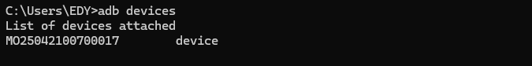
- Obtain Administrator Privileges
Input “adb root”:Obtain Android Administrator (Root User) Privileges
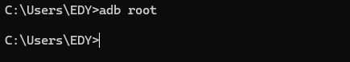
- Uninstall app package
Input “adb uninstall com.ezhan.amr”
- Install app package(apk package)
Command: adb install <apk_file_path>
